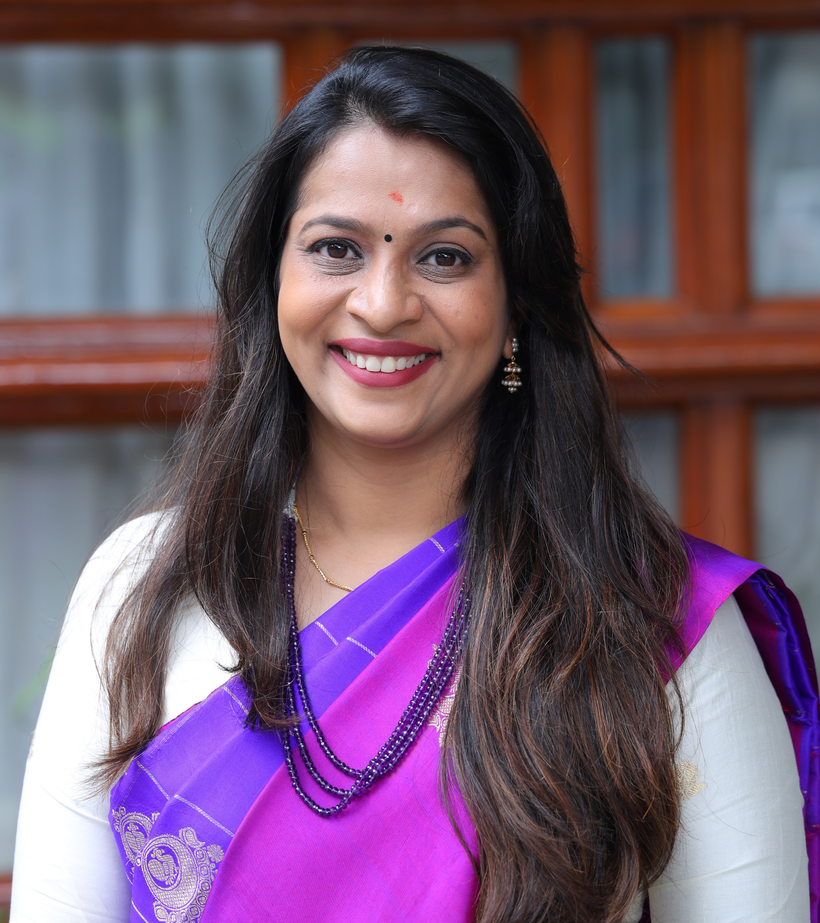
Dr. PAVITHRA NAGARAJ

Senior Consultant Pediatric and Adolescent Endocrinology
MSMC- NARAYANA HEALTH CITY, Bengaluru

 PERSONAL DETAILS

+91 80 71222222 , 9845154513

pavitranag@gmail.com, pavithra.nagaraj.dr@narayanahealth.org

Date of Birth: 11/05/1984, Age: 35 years, Gender: Female

Nationality: Indian, Languages spoken: English, Hindi, Kannada

- SECRETARY -(Pediatric Endocrinology Association of Karnataka, India)- 2024-26

- Executive board member- IAP- Bengaluru, 2024, 2025, 2026

- JOINT SECRETARY AND TREASURER of PEAK (Pediatric Endocrinology Association of Karnataka, India)- 2022-24

- Faculty for the IDEAL Program (ISPAE Diabetes education and Learning): an online educator course for pediatric diabetes educators (Certified Diabetes Educator Course)

- Faculty for the BEST IDEAL program- A Basic online educator course for the nurses and the paramedicals

- Reviewer for the journal - CHRONICLES OF DIABETES RESEARCH AND PRACTICE

- Part of the ACT clinic ( After Completion Therapy) for cancer patients in association with Indian Society of Cancer

- JOINT ORGANIZING SECRETARY and TREASURER, ISPAE-2023

 EDUCATION

* Fellowship in Pediatric and Adolescent Endocrinology: January 2019.
Indira Gandhi Institute of Child Health, Bengaluru, India.
Rajiv Gandhi University of Health Sciences, Bengaluru, India.

* Joint EASD/ISPAD/ESPE Postgraduate course: November 22nd- 24th, 2018.
Type 1 diabetes in Children, Adolescents and Young Adults, PRAGUE, Czech Republic.

* Post-graduation: MD Pediatrics, May 2012.
Jawaharlal Nehru Medical College, Belgaum, KLE University.

* Graduation:MBBS, April 2008.
Ramaiah Medical College & Research Institute,
Rajiv Gandhi University of Health Sciences, Bengaluru, India.

CONFERENCES/ PRESENTATIONS

- “Dakshin Pedicon- 2024”, Thrissur, Kerala :
Faculty for the workshop on Pediatric Endocrinology: Topic: Pubertal disorders in Children”
Panelist on the topic “Pediatric Endocrine Emergencies”

- “KARPEDICON 2024”, October: As a panelist on the topic “Adolescent Obesity: Challenges in Management” at JJSS, Mysuru

- Bangalore Pedicon 2024 :Faculty for “Gateways to Airways” Workshop- Presidential Action Plan
Faculty for the topic “Stature surveillance: Advancing Growth Monitoring
Strategies” at NIMHANS, Bengaluru

- Faculty for Teens to Tots: Pediatric Obesity symposium, May 2024

- Talk on Under-Nutrition in Children: Consequences and Management at Mysuru organised by the IAP- Mysuru branch, May 2024

- PEDICON 2024: 24-28th Jan 2024 at Cochin, India
Faculty: Rickets Revisited, diagnosis and management of Resistant Rickets

- “KARPEDICON 2023”, October : As a faculty for the workshop on Pediatric Endocrinology at Gulbarga.

- Bangalore Pedicon 2023 :Panelist for the topic “Growth monitoring in office practice” at NIMHANS, Bengaluru

- HORMONE RHYTHM, 2023: Annual conference of Karnataka Endocrine Society, as a Panelist on the topic “Rickets: From simple to Resistant forms” held at Belagavi

- International pediatric endocrinology conference (IPEC), Nov, 2022: as a panelist on the topic “PCOS”, a virtual conference

- TOT, Novemeber, 2022: As a faculty at Baptist Hospital, Bengaluru, on the topic “vitamin D deficiency and rickets”

- “SOUTH PEDICON 2022”, September, 2022: As a panelist on the topic “Neonatal Endocrinology” at JNMC, Belagavi

- Faculty for the Pediatric Endocrinology workshop: “Growth and Puberty - A Challenging Journey” as a part of South Pedicon

- Bangalore Pedicon 2022 :Panelist for the topic “Sweet Children- Diabetes in Children” at NIMHANS, Bengaluru

- Bangalore Pedicon 2022 : Faculty for the workshop on pediatric endocrinology at Manipal hospitals, Bengaluru

- CME at Ashwini Ayurvedic Medical College and Research Institute, Tumkur: June 22nd 2022

- PEDICON 2022: 19-23rd March 2022 at Noida, India
Faculty for the TOT- Pediatric Endocrinology

- PEDICON 2022: 19-23rd March 2022 at Noida, India
Panelist for thyroid disorders in children

- CME across the state Karnataka as a speaker:
Kolar- 8th November, 2024
Bagalkot Distric- 13th March 2022
Davanagere- &th April 2022
Tumkur - 17th April 2022
Raichur - 3rd July 2022

- Speaker : PEDENDOCON: 2022- Annual Conference of Pediatric Endocrinology kerala chapter- Growth charts and approach to short stature- hands on -

- Panelist at PEDENDOCON 2022- Annual Conference of Pediatric Endocrinology kerala chapter- On Endocrinological issues in children with THALASSEMIA

- ISPAE 2021: Virtual Meet, 12th -13th November, Pune, India.
Indian Society of Pediatric and Adolescent Endocrinology, 7th Biennial Meeting

- APPES 2021: November 2021, Virtual Conference held at Kuala Lumpur, Malaysia

- Bangalore Pedicon: September 2021, Bangalore

- ISPAE 2019: 29th November- 1st December, 2019, Kolkatta, India.
Indian Society of Pediatric and Adolescent Endocrinology, 6th Biennial Meeting.

- APPES Fellows school: November 2018, Chiang Mai, Thailand.
Case presentation on Syndromic Peripheral Precocious Puberty.

- 10th APPES conference: November 2018, Chiang Mai, Thailand.
Asia Pacific Pediatric Endocrine Society.
Poster presentation on:
1. Precocious puberty in boys- different etiology.
2. Type 1 diabetes mellitus: a missed diagnosis.

- ISPAD: October 2018, Hyderabad, India.
International Society of Pediatric and Adolescent Diabetes.
Poster presentation on:
1. Diabetic neuropathy- An early presentation.
2. APS II- a diagnosis not to miss.

- PEDICON: January 2017, Bengalooru, India.
Part of the organizing committee.

- ICPID: March 2017, Bengalooru, India.
International conference on primary immunodeficiency diseases.

- Bangalore pedicon: 2014, NIMHANS, Bengalooru, India.

- Adolescon: July 2009, Belgaum, India.
Part of the organizing committee.

DISSERTATION TOPIC

A cross sectional study conducted in the schools of Belgaum city, Karnataka, India to study the prevalence of metabolic syndrome in the age group 13- 16 years and to know the risk factors associated with the same.
WORK EXPIRIENCE

* April 2019 till date: Consultant,
Pediatric and Adolescent Endocrinology.
MSMC- Narayana health city, Bangalore.

* Jan 2018- Jan 2019: Fellowship in Pediatric and Adolescent Endocrinology.
Indira Gandhi Institute of Child Health, Bengaluru, India.
(on study leave from Ramaiah medical college, Bengaluru, India).

* Nov 2014- Mar 2019: Assistant professor, Department of Pediatrics.
Ramaiah medical college, Bengaluru, India.

* Jan 2014- Oct 2014: Assistant professor, Department of Pediatrics.
Dr.B.R.Ambedkar medical college, Bengaluru, India.

* June 2012- Dec 2013: Senior registrar, Department of Pediatrics.
Chord road hospital, Bengaluru, India.

* May 2009- May 2012: Junior resident, Department of Pediatrics.
JNMC [KLE], Belgaum, India.
PUBLICATIONS/ OTHERS

* AN INTERVENTIONAL STUDY TO DETERMINE THE PREVALENCE OF EXERCISE INDUCED ASTHMA IN SCHOOL CHILDREN AGED 9- 18 YEARS (PES.2022-0083) has been submitted to Pediatric exercise science.

* Publication : DIBETES IN CHILDREN in a kannada magazine “SUTRA” which deals with Science and Health 2022

* Speaker : Obesity and precocious puberty (VIRTUAL EVENT) on womens day to the employess of BOSCH in 2021

* Conducted the WDD - World Diabetes Day in Mazumdar Shaw Medical Centre- Narayana Health City Bangalore with children with Type 1 Diabetes - November 2021 along with Children Day

* Publications in TOI on OBESITY and PRECOCIOUS PUBERTY - in 2021

* Thalassemia society of Bangalore - Annual meet - Speaker 2020

*A Table Tennis player. Bronze medal for Karnataka state, India in Table Tennis.
Represented the state a number of times at the national level.
Represented the RGUHS University, Bengaluru, India several times in Table Tennis.

* Awarded the KREEDA JYOTHI by the Chitradurga Mutt for the contributions in the field of Table Tennis

* I have given 3 TV shows in the local language, Kannada on – Gadget kids and homemade remedies (ZEE Kannada- FAMILY DOCTORS)- 2017
Talk in doordarshan - 2025 - on adolescent
* SCHOOL TALKS: at SFS, Avin International and Greenwood International Schools

* RADIO talk: on short stature played at 94.3FM Radio, 2024
REFERENCES

1. Prof. Dr. P. Raghupathy.
Head and chief of Pediatric and Adolescent Endocrinology
IGICH, Bangalore.

2. Dr.Vishwanath Gundappa Patil MD (Paed)
Professor, Department of Pediatrics,
Registrar, JNMC, Belgaum, India.

3. Dr. Devi Prasad Shetty
Cardiac Surgeon, Chairman and Founder of Narayana Health.
Bangalore, India

