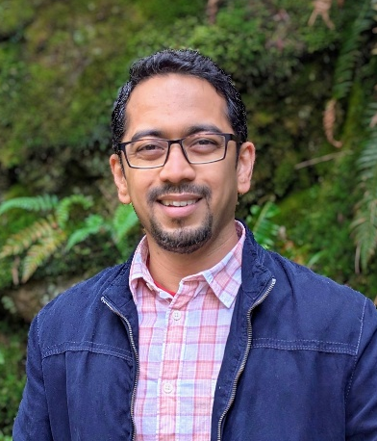
Brief Biodata: Dr Tushar Godbole
Name: Dr Tushar Godbole
Degree: MBBS, DCH, DNB, PDCC Pediatric Endocrinologist
Designation: Pediatric Endocrinologist
Position:
- Director, Harmony health Specialty Clinic, Nashik.
- Associate Prof. Dr Vasantrao Pawar Medical College, Nashik
Previous Work Experience:
- Served TWICE as Executive Board Member of ISPAE 2015-16 and 2019-20.
- Organizing Secretary, ISPAE mid-term 2016 in association with ISPAD. Worked closely in collaborating between ISPAE and ISPAD for this very first Diabetes Theme Conference.
- Conducted ISPAE Workshop on Pediatric Diabetes: 2016
- Faculty at various conferences including ISPAE, ISPAD, PEDICON
- Core faculty for ISPAE-IDEAL course
- Contributing author to various textbook chapters including Ghai’s Textbook, IAP Textbook of Endocrinology, PG Textbook of Pediatrics
- Contributing author to numerous research papers, clinical practice guidelines and review articles.
- Reviewer for journals such as BMJ, IP, IJP and JPEM
- Conducting awareness and educational programs for T1D community

My vision:
- Liaison between ISPAE’s policy makers and government authorities
- Working on legalities of pediatric endocrine practice
- Formulate consent forms for various procedures and treatment options
- Working for universal thyroid screening and free insulin availability at National Level

